Punjab University College Of Information And Technology

Homework # 1+2+3



### Home Work # (1+2+3)

**Submitted By:**

**Submitted To:**

Imran Munawar MCSF19A027

**Subject :**

**Haq Nawaz**

**Mobile Computing**

**GitHub Account**

Create a Account on github.com:



***Logo of github***

### GitHub Repository:-

Create a repository on GitHub:

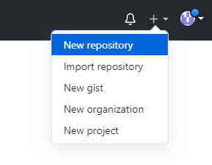

Provide Details of repository on your Account:

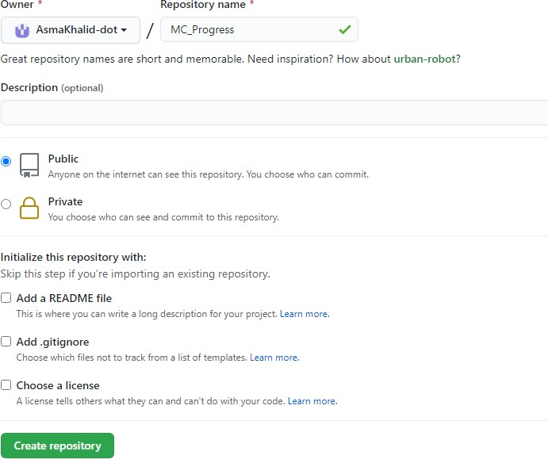

url of repository on your Account:

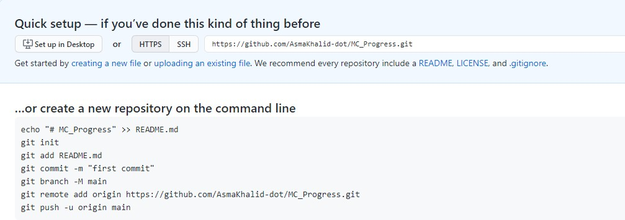

# Git Clone

Clone a repository:

git clone:

***https://github.com/Imran-dot/MC01.git***

# File Content

Created simple html file at local repository:

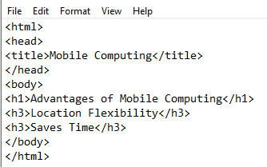

## Git Add

Adding file to repository:

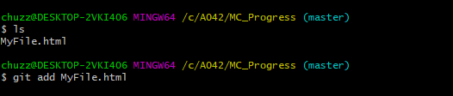

## Git Commit

Changes made with message to track changes:

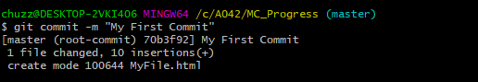

## Git Status

Tells about the status of the repository:

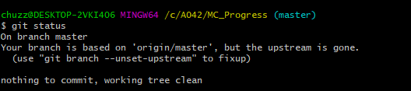

## Git Push

Push changes to the server:

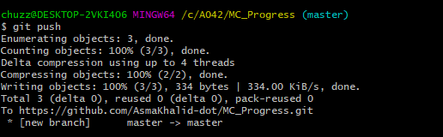

## GitHub Repository

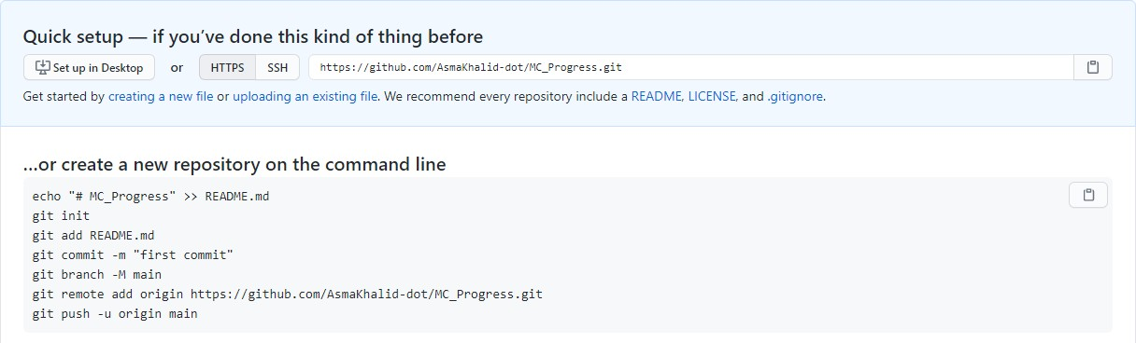

***url of repository on your account:***

view of repository after push:

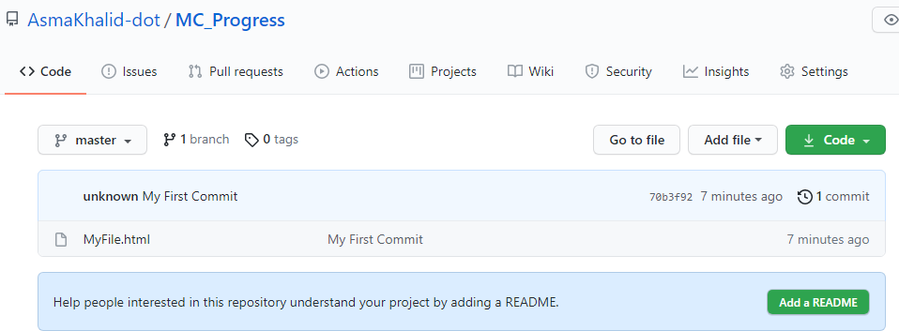

content of file in repository:

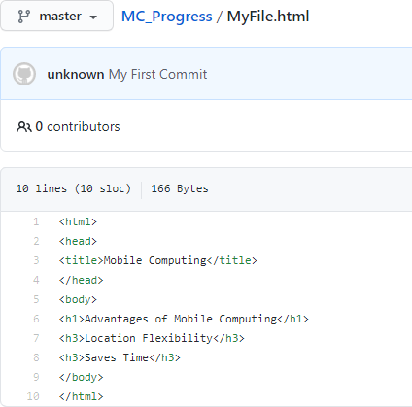

# File Content

changes made at local repository:

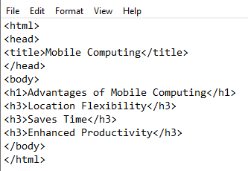

## Adding new commit

Committing changes to repository:

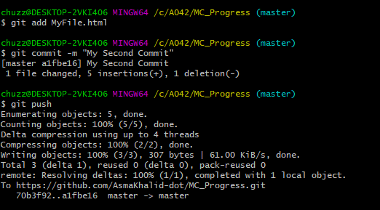

## GitHub Repository

view of repository after second push:

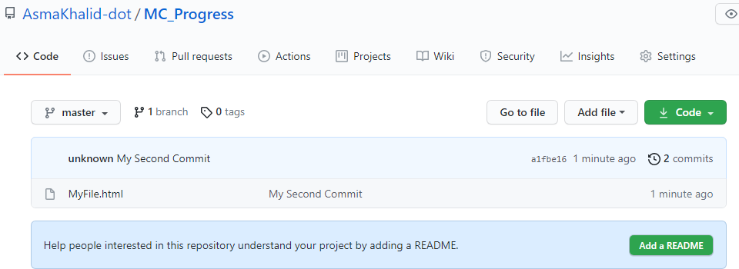

## GitHub Repository

Track of changes:

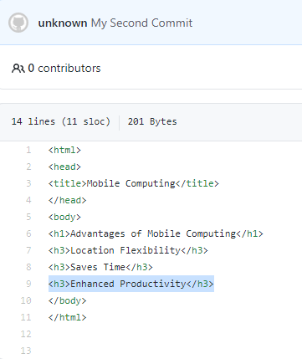

## Edit Online

How to edit files at repository:

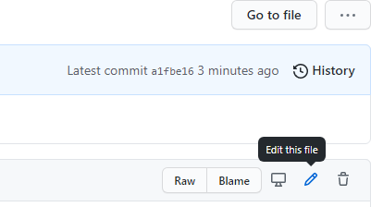

## Edit Online

How to edit files at repository:

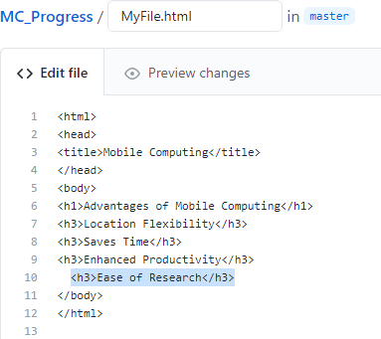

## Commit changes at Web

How Commit at repository:

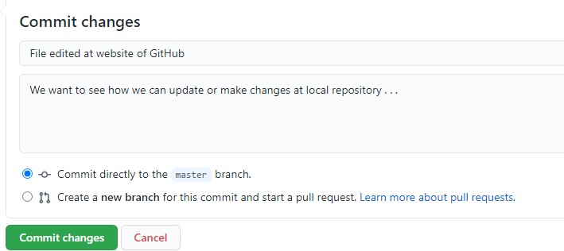

## View changes

To view changes made online repository:

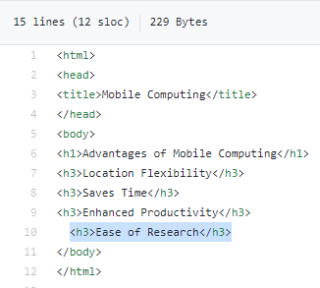

## Version Hierarchy

File showing with latest commit:

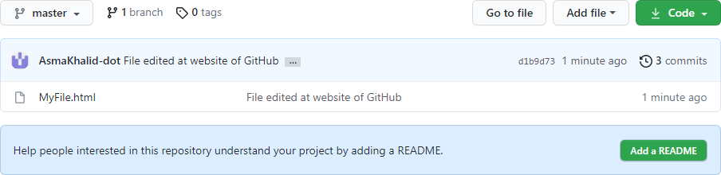

## Version Hierarchy

File showing with latest commit:

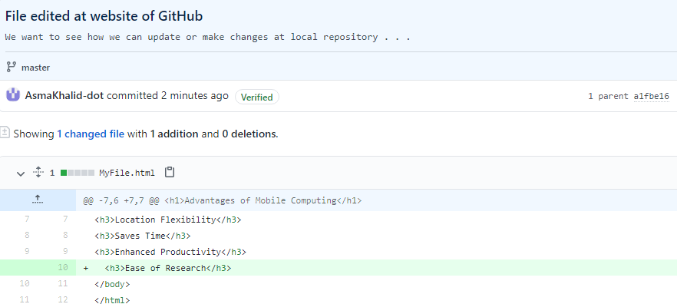

## Git Pull

To get changes from Github to local repository:

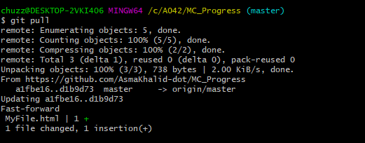

## Git Pull

To get changes from Github to local repository:

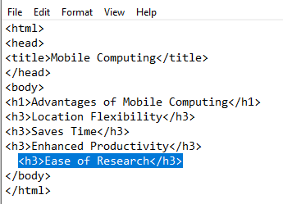

## Merge Conflicts

File changed at github.com:

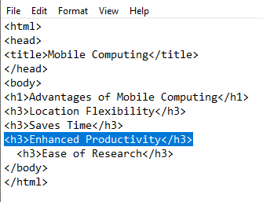

## Merge Conflicts

Same line changed at local repository:

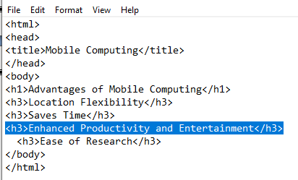

## Merge Conflicts

Git add,commit and push:

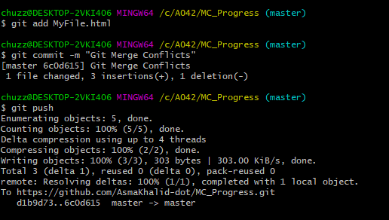

## Merge Conflicts

Same data at github.com:

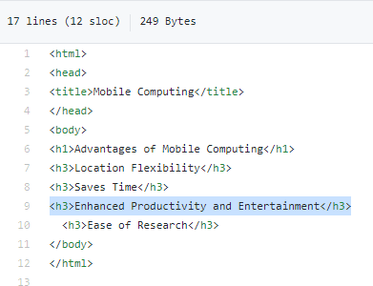

Details of commits:

# Git log

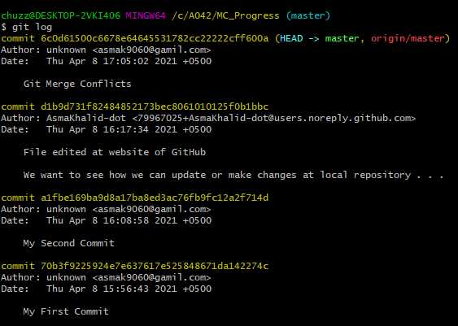

Create a Branch:

* git branch
* git check
* git merge

# Branching

Create a Branch:

# Branching

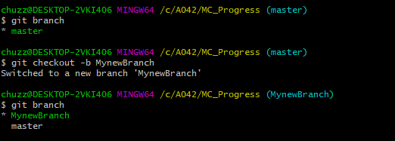

Create a Branch:

# Branching

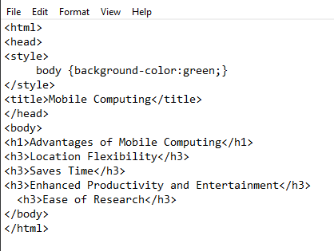

Commit Added:

# Branching

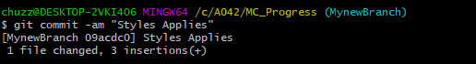

**Branching**

Switch to Master Branch:

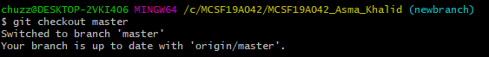

Master Branch:

# Branching

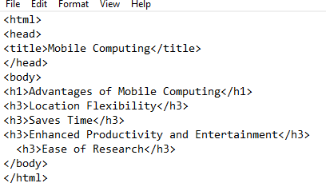

**Branching**

Switch to Newbranch Branch:

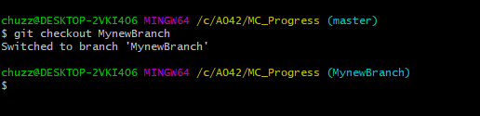

Newbranch Branch:

# Branching

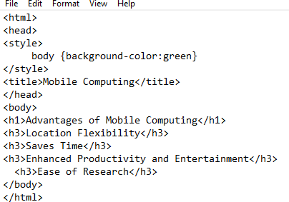

**Merge**

Merge different branches:

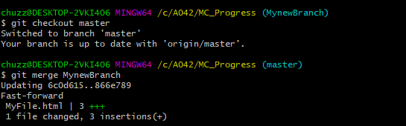

Main Branch:

# Branching

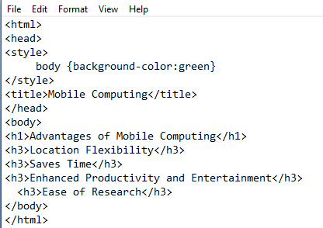

Main Branch:

# Delete Branch

